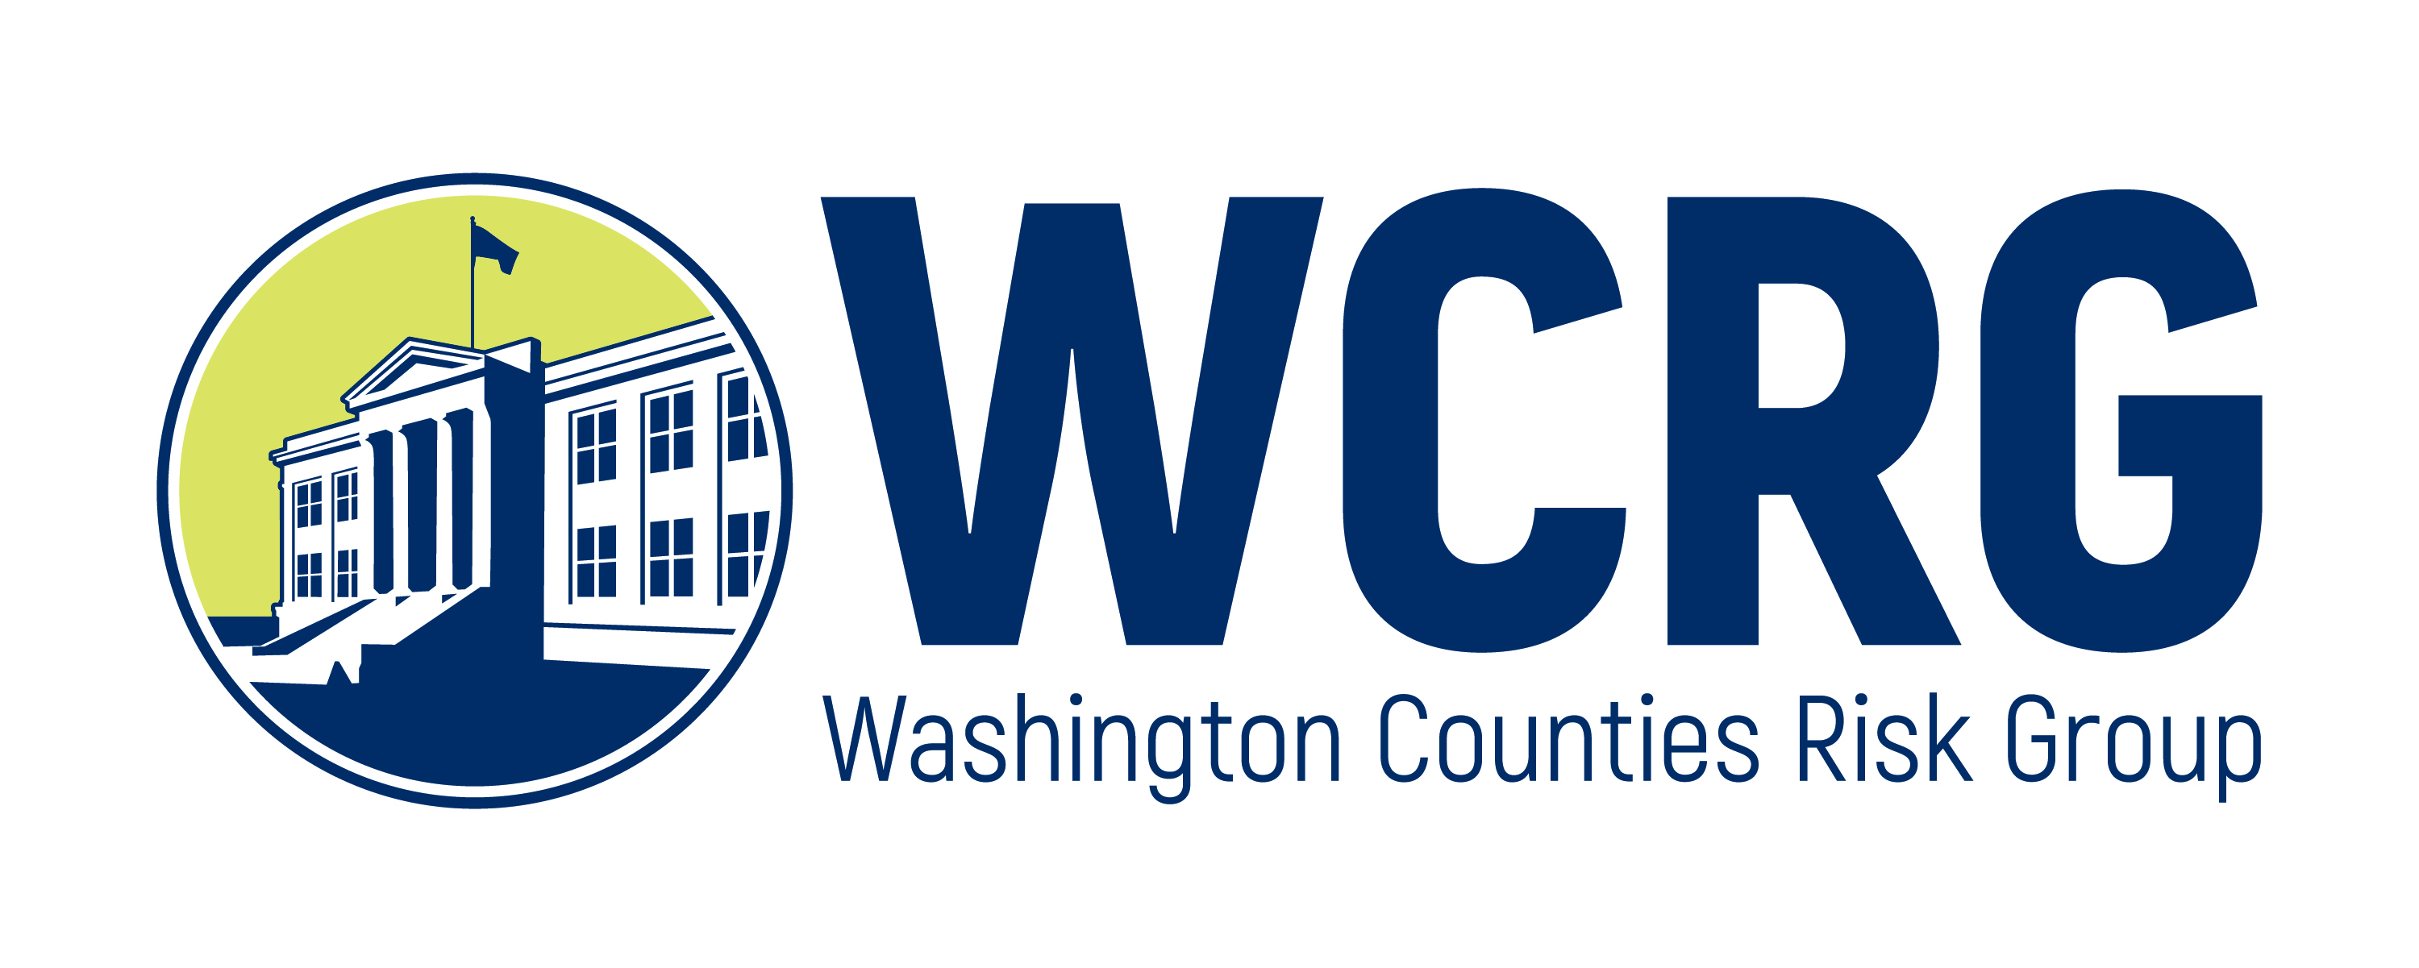
WASHINGTON COUNTIES RISK GROUP
Application for Loss Control Scholarship Funding

Applications will be considered by degree to which risk may be reduced, by order of date received, and within the scholarship funds available.

Last Name:
First Name:
Member Entity:
Your Title:
Part Time Full Time
Mailing Address:
Email: |  |  | Phone:
Primary Duties:
REQUEST FOR ASSISTANCE BELOW
Education
Type:
Location:
Date:
Sponsored By:
Describe reason or need for scholarship funds and how it will reduce claims or liability: (use separate sheet, if needed)

Scholarship are awarded for trainings related directly to raising the member’s risk related knowledge and improving overall safety of the member’s organization.

Amount You are Requesting:
 |  | Training total: | $
 |  | Member matching funds: | $
 |  | Funds from other sources: | $
 |  | Other (Describe below): | $
 |  | TRAINING TOTAL: | $
Please see scholarship guidelines for required attachments to this request.

I hereby apply for scholarship funds for training:
and attest that the information submitted in and with the application is true and accurate to the best of my knowledge.

 | Signature of Applicant |  |  |  | Date

I hereby support scholarship requested funds for applicant for training:
Please feel free to attach a more detailed letter of support and submit that with the application. If you are unable to obtain a letter, a signature from management of support will suffice.
 | Signature of Management |  | Date

Please submit this application to:
Washington Counties Risk Group
Board of Directors
451 Diamond Drive
Ephrata, WA 98823
(800) 407-2027 ext 4014
msherwood@chooseclear.com

